CENTRAL UNIVERSITY OF HARYANA
DEPARTMENT OF COMPUTER SCIENCE AND ENGINEERING
SCHOOL OF ENGINEERING AND TECHNOLOGY



C++ PROGRAMMING LAB
BT CS 405

Submitted by
Rudra Chinhara
B. Tech CSE (2nd Year)
Roll no: 202117
Group 3

Submitted to
Ms. Tanuja

INDEX
S. No | Program Name | Page No. | Date | Signature
1. | Write a program to read a matrix of size m * n from the keyboard and display the same using functions | 3
2. | Program to make an inline function | 4
3. | Write a function power ( ) which raises a number m to a power n. The function takes the double value of m and the  integer value of n and returns the result. Use a default value of n is 2 to make the function calculate  squares when this argument is omitted. | 5
4. | Program to show that the effect of default arguments can be alternatively achieved by overloading. | 6
5. | Write a class ACCOUNT that represents your bank account then use it.  The class should allow you to deposit money, withdraw money, calculate interest,  send you a message if you have insufficient balance. | 7
6. | Write a class STRING that can be used to store strings, add strings, equate strings, output string | 9
7. | Programs to demonstrate the concept of:  a) Default Constructor  b) Parametrized Constructor  c) Copy Constructor  d) Constructor Overloading | 11

Lab-1
Write a program to read a matrix of size m*n from the keyboard and display the same using function.
Code
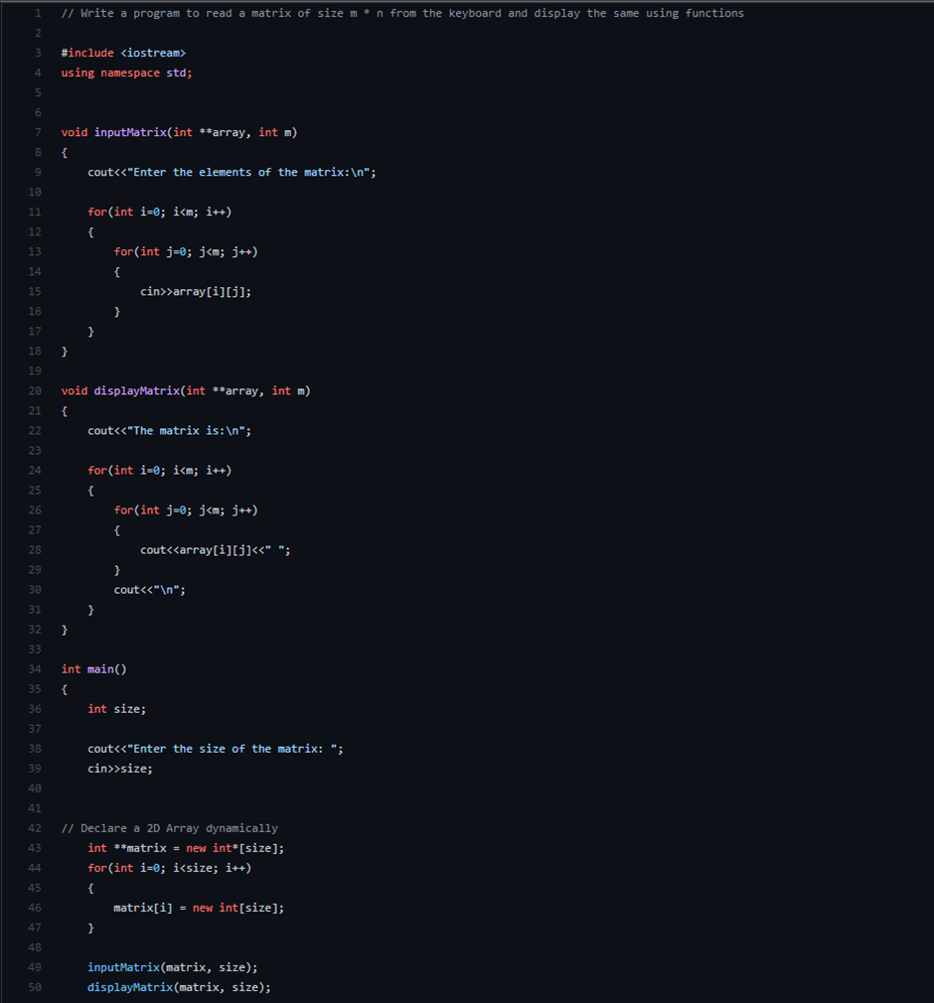
Output
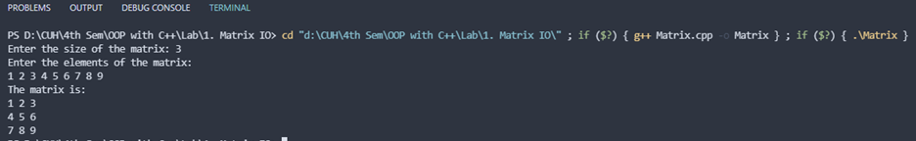

https://github.com/RPChinhara/OOP_Assignments/blob/master/1.%20Matrix%20IO/Matrix.cpp

Lab-2
Write a program to make an inline function.

Code
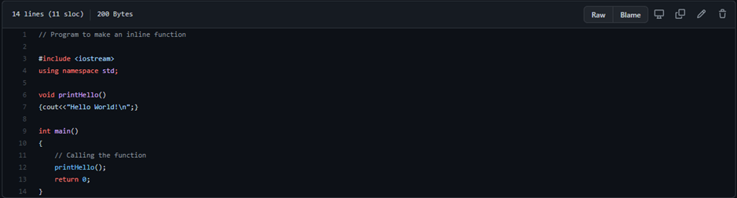
Output

https://github.com/RPChinhara/OOP_Assignments/blob/master/2.%20Inline%20Functions/InlineFunction.cpp

Lab-3
Write a function power () which raises a number m to a power n. The function takes the double value of m and the integer value of n and returns the result. Use a default value of n is 2 to make the function calculate squares when this argument is omitted.

Code
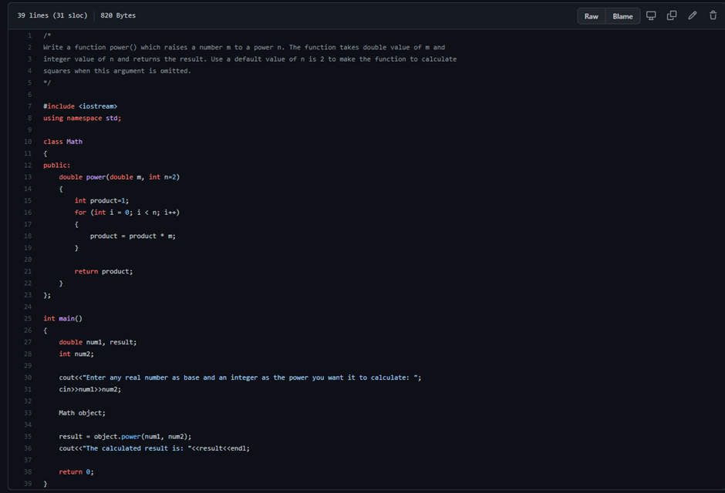
Output

https://github.com/RPChinhara/OOP_Assignments/blob/master/3.%20Power%20Function/PowerFunc.cpp

Lab-4
Program to show that the effect of default arguments can be alternatively achieved by overloading.
Code
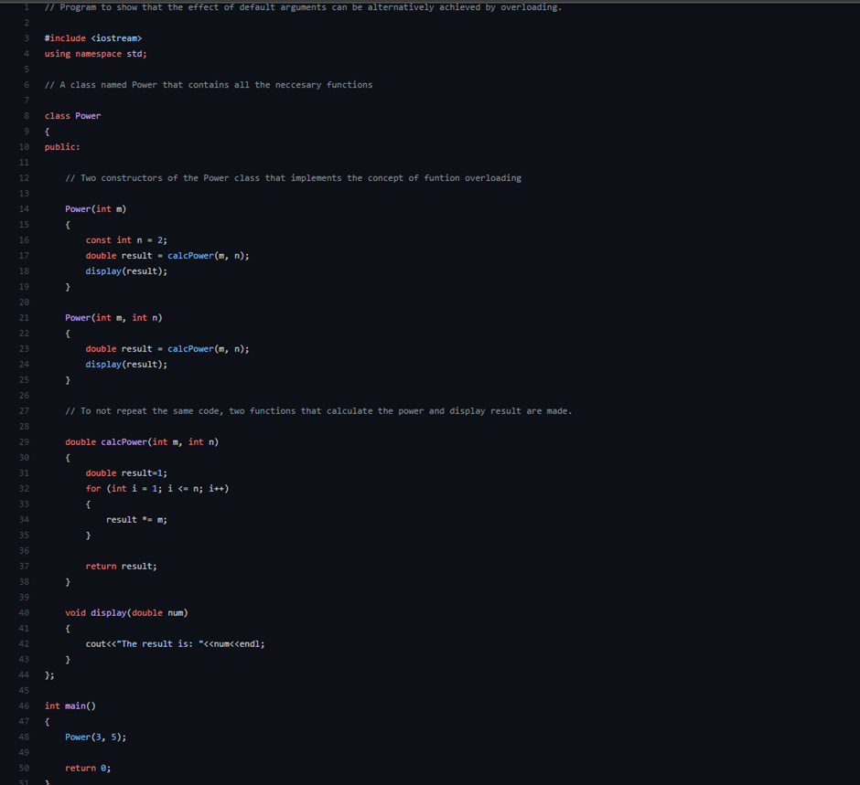
Output

https://github.com/RPChinhara/OOP_Assignments/blob/master/4.%20Funtion%20Overloading/FunctionOverloading.cpp

Lab-5
Write a class ACCOUNT that represents your bank account then use it. The class should allow you to deposit money, withdraw money, calculate interest, and send you a message if you have an insufficient balance.
Code
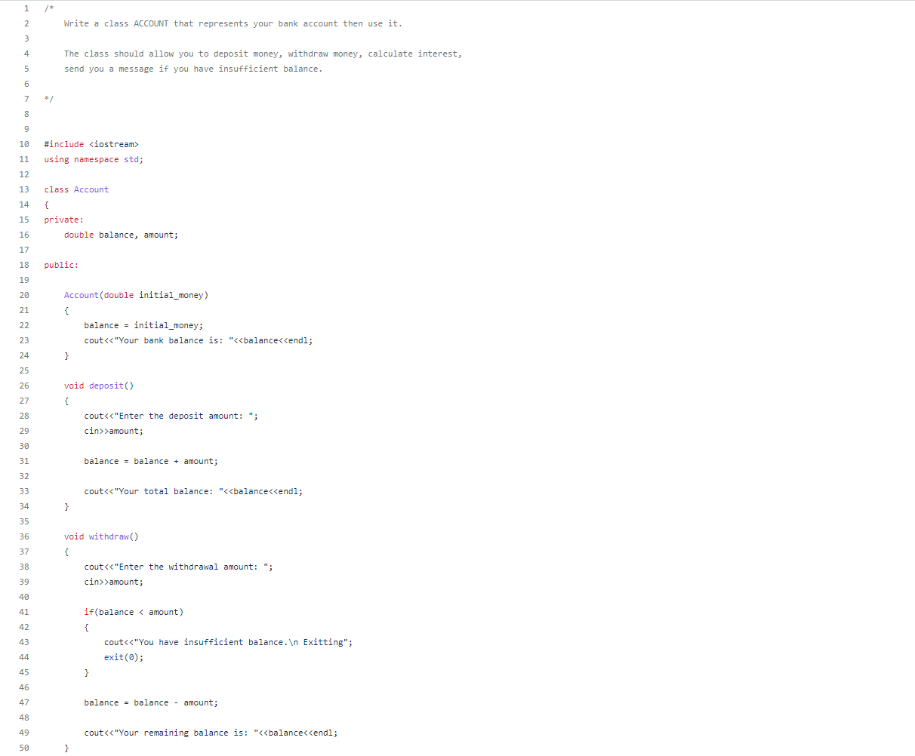
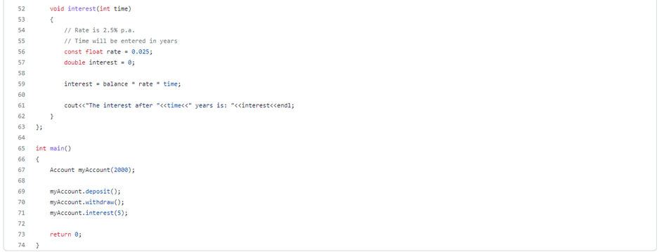

Output
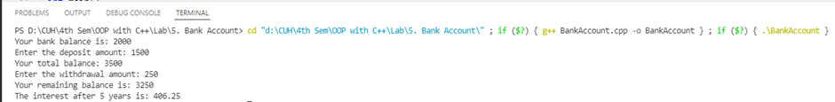

https://github.com/RPChinhara/OOP_Assignments/blob/master/5.%20Bank%20Account/BankAccount.cpp

Lab-6
Write a class STRING that can be used to store strings, add strings, equate strings, and output strings.
Code

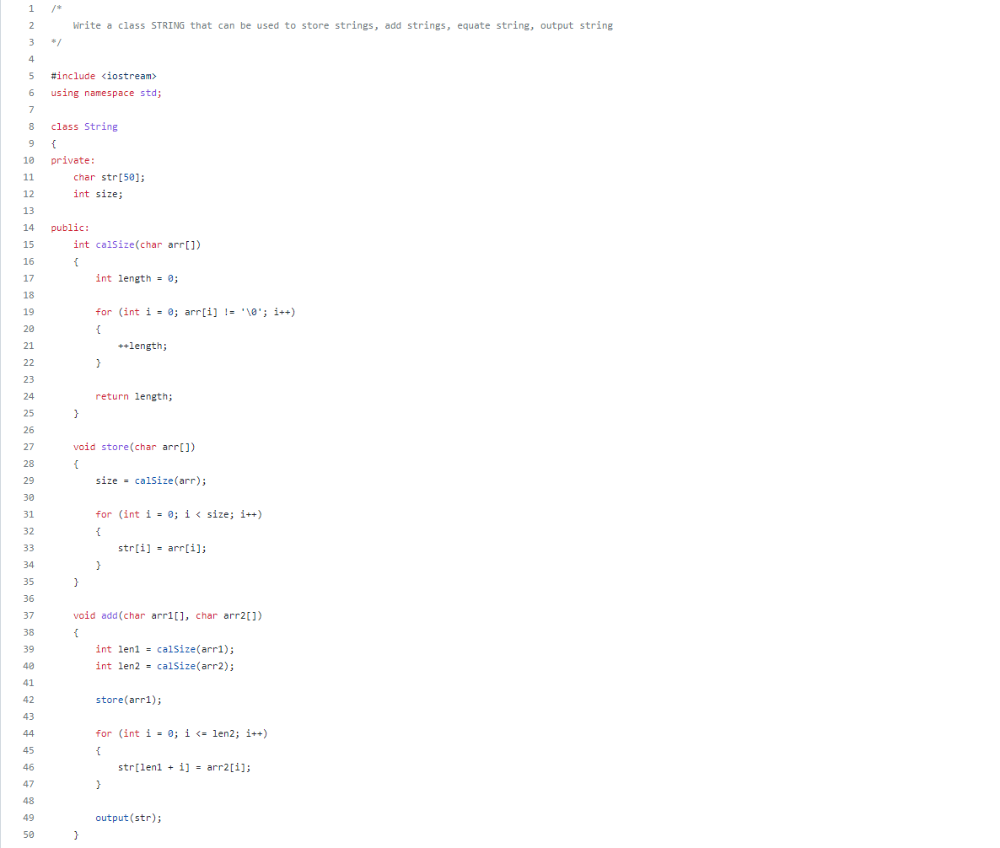

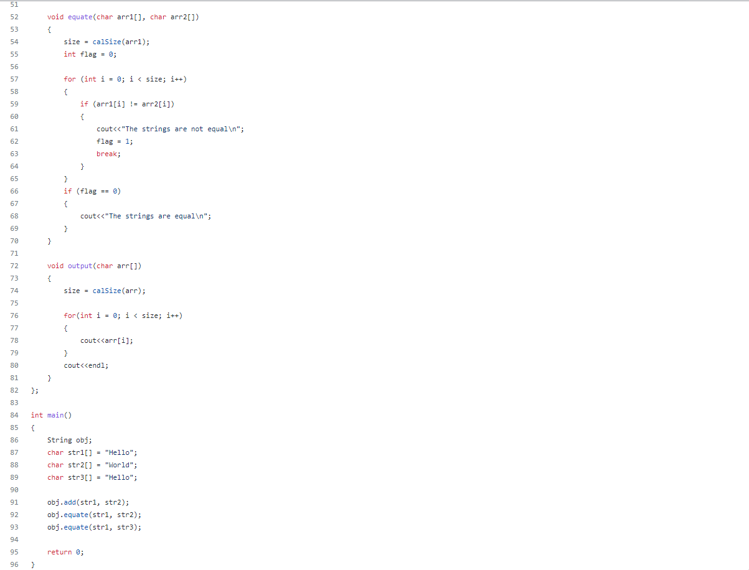

Output
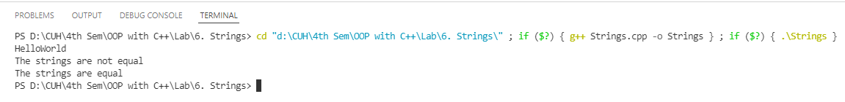

https://github.com/RPChinhara/OOP_Assignments/blob/master/6.%20Strings/Strings.cpp

Lab-7
Programs to demonstrate the concept of:
a) Default Constructor
b) Parametrized Constructor
c) Copy Constructor
d) Constructor Overloading
Code
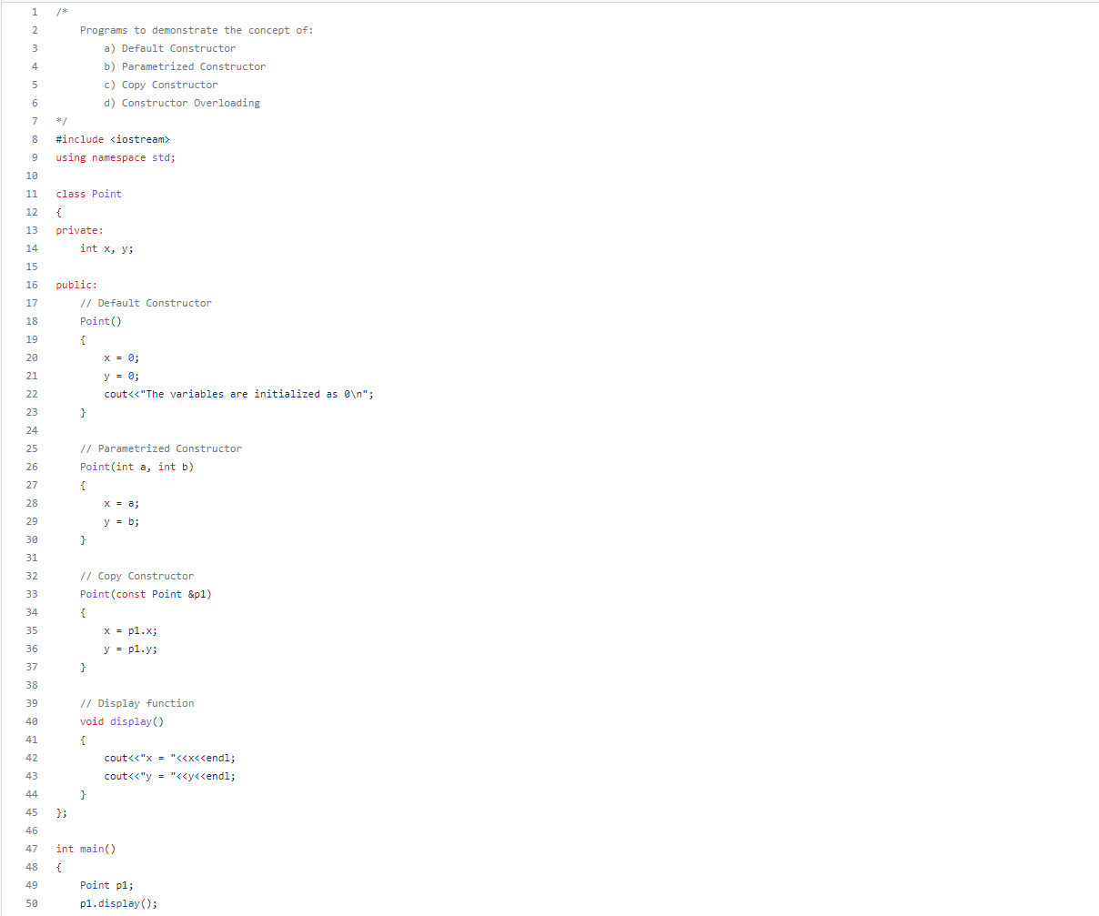
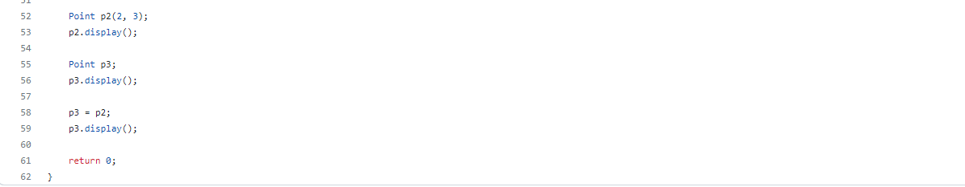

Output
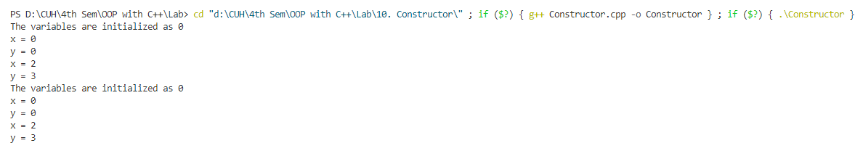

https://github.com/RPChinhara/OOP_Assignments/blob/master/10.%20Constructor/Constructor.cpp

